

FACULTY OF TECHNOLOGY AND ENGINEERING
DEVANG PATEL INSTITUTE OF ADVANCE TECHNOLOGY
AND RESEARCH

DEPARTMENT OF COMPUTER ENGINEERING

A.Y 2026 – 27 Semester – 3

LAB MANUAL

CSUC201 Fundamentals of Data Structures and Algorithms


Practical 7: Queue Implementation using Array and Linked List, with Structure Simulation

Practical Aim
Problem 1
A government office has a token counter that issues tokens to visitors. The counter can hold atmost n tokens at a time. New visitors join from one end and are served from the other end in the order they arrived. If the counter is full, no new token can be issued, and if it is empty, no one can be served. Given a sequence of join and serve operations, implement this fixed-capacity token system and print the current front token after each operation. Report an error if an operation cannot be performed.
Describe how your solution tracks the front and rear of the queue. What happens to your front and rear pointers over time as join and serve operations keep happening, and does your solution handle the case where space appears to run out even though slots have been freed?
Theory:
1. A simple array queue eventually reports being full even when slots have been freed at the front. Explain why this happens structurally — not by tracing an example, but by describing what the front and rear pointers represent and what their movement pattern causes over time.
In a simple linear array queue, the front pointer moves forward when elements are removed, and the rear pointer moves forward when new elements are added. The rear pointer does not automatically return to the freed positions at the beginning of the array. As a result, the rear can reach the end of the array and report that the queue is full even though some earlier slots are empty.

Code: https://github.com/kanan2007s-sys/FDSA_B/tree/main/Practical%201

Screenshot:
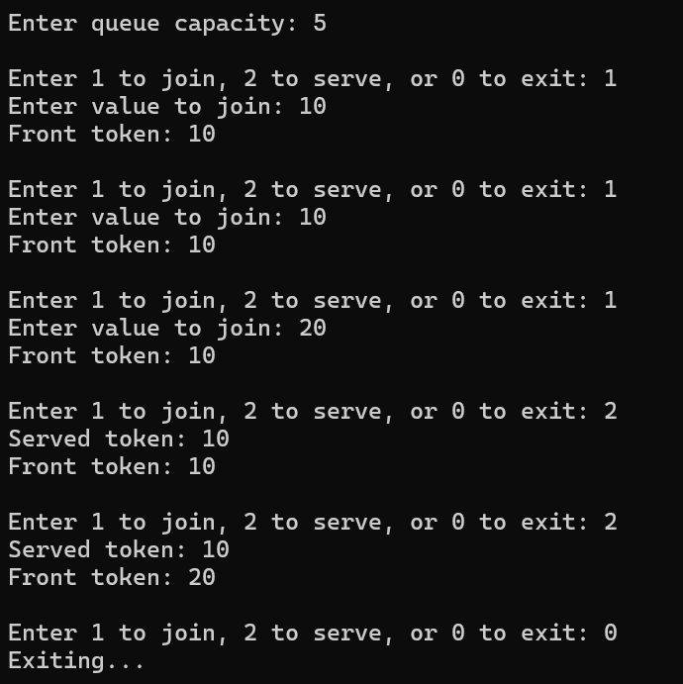
Description:
Implemented a fixed-size queue using an array.
Performed join and serve operations while displaying the front token.
Handled queue overflow, underflow, and front and rear pointer updates.

Challenge:
I faced challenge in implement queue using linked list.

Problem 2
A hospital emergency ward receives patients continuously and attends to them strictly in the order they arrived, with no upper limit on how many can be waiting at once. New patients are added at the back and the doctor always attends to the patient at the front. Given a sequence of arrive and attend operations, implement this unlimited patient queue and print the current front patient after each operation.
Describe how your solution differs from Problem 1 in how it manages capacity. What happens in your solution when the attend operation is called on an empty ward with no patients waiting?
Theory:
2. Your linked list queue has no capacity limit. If arrive operations vastly outnumber attend operations over a long period, what real consequence would this have on the system, and where in your code is that consequence invisible?
If more patients arrive than are attended, the queue continues to grow and uses more memory. Over time, this can consume the available system memory and make the program slow or cause memory allocation to fail. This limit is not visible as a fixed capacity in the queue code because each new node is dynamically allocated. If more patients arrive than are attended, the queue continues to grow and uses more memory. Over time, this can consume the available system memory and make the program slow or cause memory allocation to fail. This limit is not visible as a fixed capacity in the queue code because each new node is dynamically allocated.
Code: https://github.com/kanan2007s-sys/FDSA_B/tree/main/Practical%201

Screenshot:
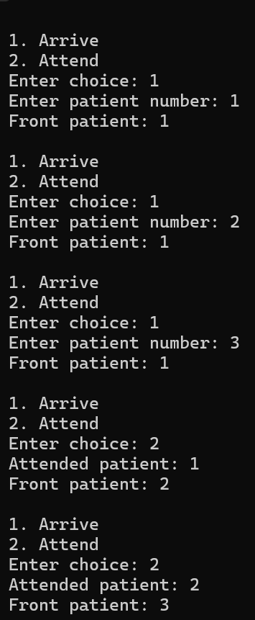
Description:
Implemented a dynamic queue using a linked list.
Performed patient arrival and attendance operations following FIFO order.
Handled an empty queue and managed nodes dynamically.

Challenge:
Only in implementing linked list using pointer.

Conclusion:
Successfully implemented queues using arrays and linked lists and understood FIFO operations, capacity management, and pointer updates.

